**Comprehensive Report on Vision Transformer for Metal Surface Defects Detection**

The Python script provided focuses on using TensorFlow and Keras to build a Vision Transformer (ViT) for object detection. This study provides a thorough examination of the screenplay, focusing on its key ideas, working techniques, and consequences.

**Detailed Description:**

**1. Initialization and Data Loading:**

Before accessing data, the script first mounts Google Drive. It imports the necessary libraries, configures the Keras backend, and defines the directory paths for the images and annotations. After loading the image and annotation files, the script prints the annotation routes so they may be verified.

**2. Data Preprocessing:**

The script handles data preprocessing, specifically for XML annotation files. Bounding box coordinates are obtained by processing the related XML files and iterating over the image URLs. After shrinking the images to a preset size, the data is saved in lists for later processing.

**3. ViT Model Architecture:**

**3.1. Patch Extraction and Encoding:**

The script includes a specific Patches layer that allows you to extract patches from input photographs. A PatchEncoder layer then encodes these patches using projection and position embedding. Several Transformer blocks are included in the model design to aid in feature extraction.

**3.2. Transformer Blocks:**

The ViT model is made up of numerous transformer blocks, each containing multi-layer perceptrons (MLP), layer normalization, skip connections, and multi-head attention. These blocks employ input patches to learn hierarchical properties.**3.3. Output Layer:**

The model outputs bounding box coordinates to detect items. The last layers include layer normalization, flattening, dropout, and a dense layer that anticipates the bounding box.

**4. Model Training:**

The script describes a training experiment for the ViT-based object detector. The loss function is defined as Mean Squared Error, and the model is compiled using the AdamW optimizer. Early stops and checkpoints are used to track training. The training history is saved for future examination.

**5. Experiment Configuration:**

The experiment's hyperparameters include the learning rate, weight decay, batch size, number of epochs, patches, projection dimension, number of heads, transformer units, transformer layers, and MLP head units.

**6. Model Evaluation:**

To evaluate the model's performance with bounding box predictions, the script computes the Intersection over Union (IoU). For ten test photos, it shows forecasts alongside ground truth bounding boxes. We calculate and report the mean IoU.

**Detailed Analysis:**

**1. Model Architecture and Transformer Blocks:**

The architecture of the ViT model is suitable for transformer-based computer vision algorithms. The script successfully implements patch extraction, encoding, and several transformer blocks, allowing the model to capture complicated spatial correlations in input data.

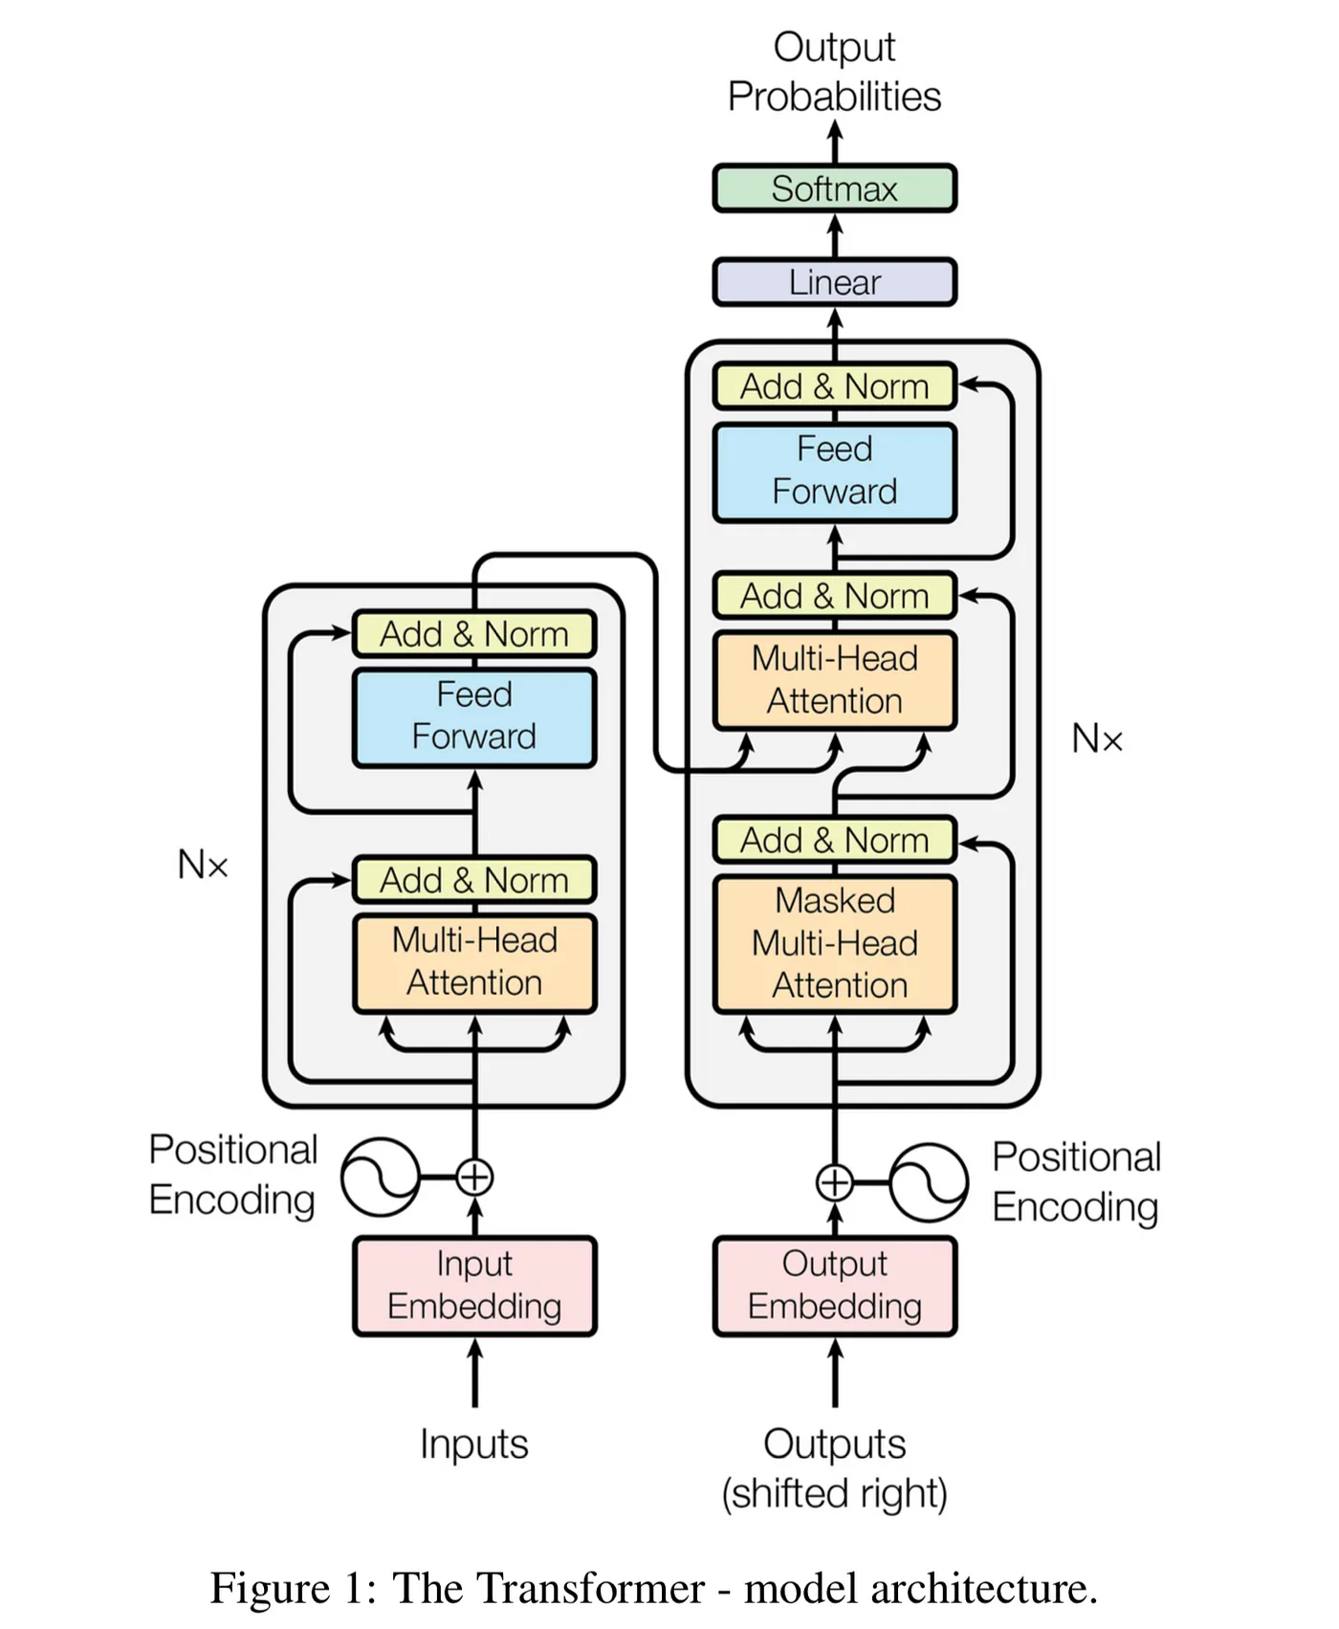

**2. Training and Optimization:**

The AdamW optimizer, a popular choice for transformer-based designs, is utilized to train the model. The script employs checkpoints to save the optimal model weights during training and early quitting to prevent overfitting.

**3. Experiment Configuration:**

Because the script's hyperparameters are configurable, users can experiment with various settings while maintaining flexibility. The architecture, weight decay, and learning rate of the ViT model are all important considerations that can be tailored to specific requirements.

**4. Evaluation and Visualization:**

The script's evaluation section is critical for determining how well the model works. Visualizing bounding box predictions with ground truth allows for a more qualitative understanding of the model's capabilities. The IoU computation provides a numerical indicator of detection accuracy.

**Results and Discussion:**

**1. Training History:**

To understand the model's convergence and generalization, look at the script's training history. Plotting training and validation loss over epochs might help identify potential overfitting or underfitting issues.

**2. Mean IoU:**

The average IoU across the ten test images reveals how effectively the model predicts bounding boxes. A higher mean IoU indicates better alignment of the predicted and ground truth bounding boxes.

**3. Visual Inspection:**

Understanding the bounding box predictions for specific test photos aids comprehension of the model's benefits and drawbacks. To build trust in the model, evaluate how closely the anticipated bounding boxes match the ground truth annotations.

**Figures for the Loss Curves and Accuracy:**

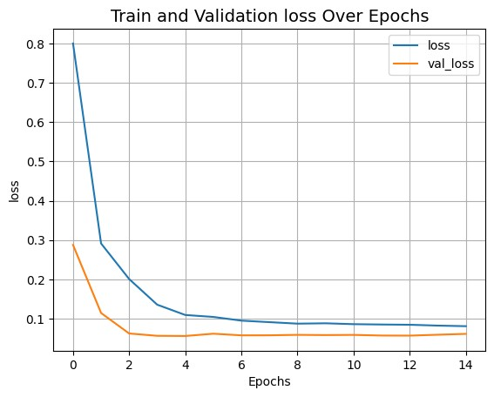

**Principle of Model Design:**

**Data Preprocessing:**

Images and annotations are loaded from specified directories.

XML annotations are parsed to extract bounding box coordinates.

**Patches Extraction:**

The Patches class is defined to extract non-overlapping patches from input images using the tf.image.extract_patches function.

The patches are flattened and reshaped into a format suitable for processing by the transformer.

**Patch Encoding:**

The PatchEncoder class is defined to encode the extracted patches using a linear projection followed by position embeddings.

The position embeddings help maintain spatial information within the patches.

**ViT Architecture:**

The create_vit_object_detector function builds the main ViT model for object detection.

It involves encoding the patches using the PatchEncoder and applying multiple layers of the Transformer block.

The model includes layer normalization, multi-head self-attention, skip connections, and a feedforward MLP.

**Training:**

The model is compiled using the AdamW optimizer and Mean Squared Error loss for bounding box regression.

Training is performed using the run_experiment function, including early stopping and model checkpointing.

**Hyperparameters:**

Hyperparameters such as learning rate, weight decay, batch size, number of epochs, patch size, and model dimensions are defined.

**Visualization:**

The training history is plotted to observe the loss over epochs.

The trained model is saved.

**Evaluation:**

Intersection over Union (IoU) is calculated to evaluate the accuracy of the predicted bounding boxes compared to ground truth.

**IoU Calculation:**

The bounding_box_intersection_over_union function calculates the IoU between predicted and ground truth bounding boxes.

**Testing and Visualization:**

The trained model is applied to a subset of the test data, and the predicted bounding boxes are visualized alongside the ground truth.

**Mean IoU Calculation:**

The mean IoU is calculated over a subset of test images.